**ANALOG CLOCK**

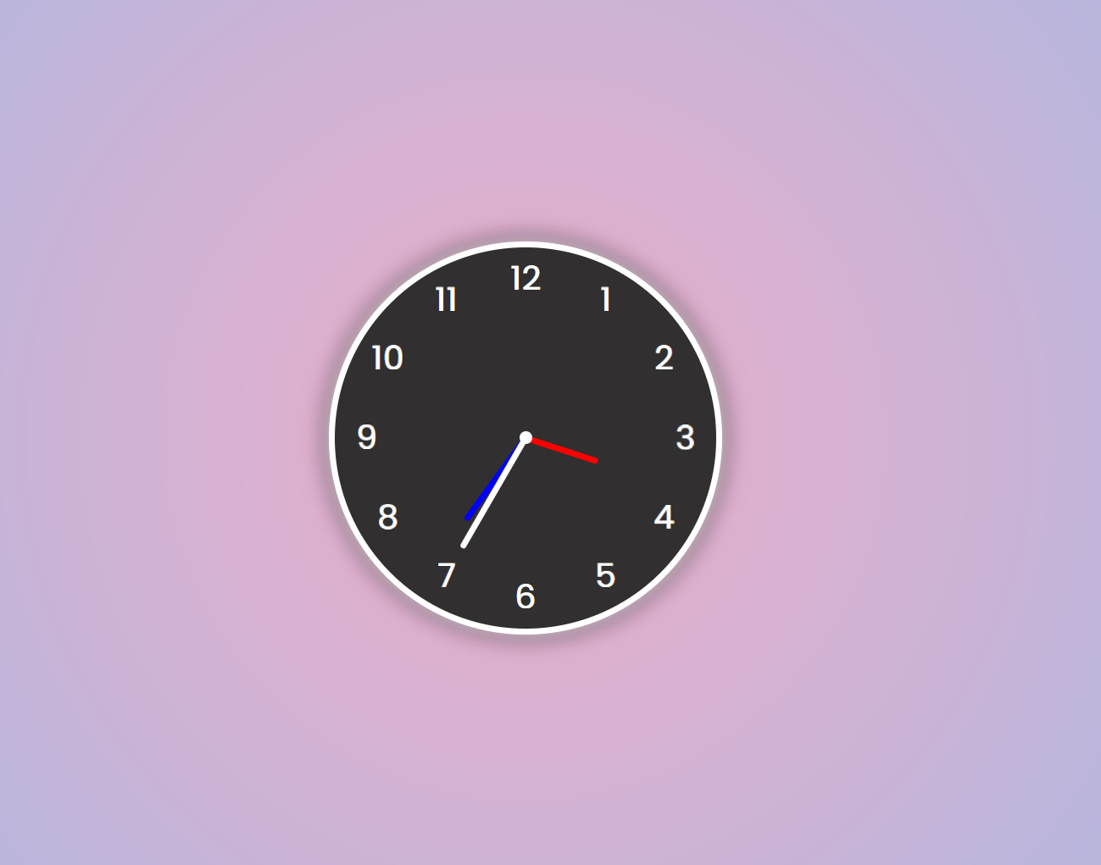

An analog clock is a traditional timekeeping device that displays time

through the position of hands on a circular dial. It consists of an hour

hand, a minute hand, and sometimes a second hand.

HTML

<!DOCTYPE html>

<html lang="en">

<head>

<meta charset="UTF-8">

<meta name="viewport" content="width=device-width, initial-scale=1.0">

<title>Analog Clock in HTML - CSS - JS</title>

<!-- Custom CSS -->

<link rel="stylesheet" href="style.css">

</head>

<body>

<!-- Clock -->

<div class="clock">

<div class="needle hr" style="--h:60px; --clr:red"><span></span></div>

<div class="needle mn" style="--h:80px; --clr:blue"><span></span></div>

<div class="needle ss" style="--h:100px; --clr:white"><span></span></div>

<ul>

<li style="--i:1"><span>1</span></li>

<li style="--i:2"><span>2</span></li>

<li style="--i:3"><span>3</span></li>

<li style="--i:4"><span>4</span></li>

<li style="--i:5"><span>5</span></li>

<li style="--i:6"><span>6</span></li>

<li style="--i:7"><span>7</span></li>

<li style="--i:8"><span>8</span></li>

<li style="--i:9"><span>9</span></li>

<li style="--i:10"><span>10</span></li>

<li style="--i:11"><span>11</span></li>

<li style="--i:12"><span>12</span></li>

</ul>

</div>

<!-- Custom JS-->

<script src="script.js"></script>

</body>

</html>

CSS

@import url('https://fonts.googleapis.com/css?family=Poppins:wght@300;400;700&display=swap');

* {

margin: 0;

padding: 0;

}

body {

font-family: 'Poppins', sans-serif;

background: rgb(238, 174, 202);

background: radial-gradient(circle, rgba(238, 174, 202, 1) 0%, rgba(148, 187, 233, 1) 100%);

position: relative;

display: flex;

justify-content: center;

align-items: center;

height: 100vh;

}

.clock {

background-color: rgb(49, 47, 47);

width: 300px;

height: 300px;

border-radius: 50%;

color: #fff;

border: 5px solid #fff;

box-shadow: 0px 0px 10px rgba(255, 255, 255, 0.7), 0px 0px 20px rgba(0, 0, 0, 0.7);

font-size: 26px;

font-weight: bold;

display: flex;

justify-content: center;

align-items: center;

position: relative;

}

.clock ul li {

list-style: none;

position: absolute;

text-align: center;

transform: rotate(calc(30deg * var(--i)));

inset: 5px;

}

.clock ul li span {

transform: rotate(calc(-30deg * var(--i)));

display: inline-block;

}

.clock:after {

content: "";

width: 10px;

height: 10px;

background-color: #fff;

border-radius: 50%;

position: absolute;

}

.needle {

display: flex;

justify-content: center;

align-items: flex-end;

}

.needle span {

width: 5px;

height: var(--h);

background-color: var(--clr);

position: absolute;

border-radius: 5px;

}

JAVASCRIPT

function show_clock() {

let h = document.getElementsByClassName('hr')[0];

let m = document.getElementsByClassName('mn')[0];

let s = document.getElementsByClassName('ss')[0];

let date = new Date();

let hours = date.getHours();

let minutes = date.getMinutes();

let seconds = date.getSeconds();

h.style.transform = `rotate(${30 * hours + minutes / 2}deg)`;

m.style.transform = `rotate(${6 * minutes}deg)`;

s.style.transform = `rotate(${6 * seconds}deg)`;

let sound = new Audio('sound.mp3');

sound.play();

}

setInterval(show_clock, 1000);